

**BLOCKCHAIN ELECTRONIC HEALTH RECORDS SYSTEM**

By

**Student Number: 101193**

An Information Systems Project Proposal Submitted to the Faculty of Information Technology in partial fulfilment of the requirements for the award of Bachelor of Science in Informatics and Computer Science.

22 June 2020

# Declaration

I declare that this project has not been submitted to Strathmore University or any other university for the award for a degree in Informatics and Computer Science or any other degree.

**Admission Number: 101193**

**Sign: ____________________________ Date: ____________________________**

**Supervisor’s Name:**

**Sign: ____________________________ Date: ____________________________**

# Abstract

*In the Kenyan healthcare system, storage of health records were stored as physically and on a large scale, with presence of vast patients, there was delayed communication, difficulty in accessing patients health information, the patient had less control of who could access their data, presence of tampered records withing the system and sharing of health records between health organizations was considered cumbersome, expensive, and almost impossible.*

*Despite adoption of electronic health record (EHR) systems in hospitals that solved the problems of storage, creation, deletion and updating of health records faced by the manual system, the challenges that arose were those of delayed communication between departments that hadn’t adopted the EHR system, high cost of development and maintenance of the EHR systems and training staff to use the EHR systems, the patient still had no control of who could access their data, lack of tools within the systems to facilitate secure sharing and transmission of health records between different health institutions due to lack of interoperability.*

*The application of blockchain in healthcare would lead to introduction of interoperability inside the system that would enable health organizations to communicate, share and utilize up to date health records between them securely and efficiently, give more control of health records to patients in terms of access, implementation of transparency inside the system that would enable easy and efficient tracking of health records and the immutability of blockchain would prevent tampering of the health records.*

*The methodology that would be applied in developing the system would be a prototype model where a model of the system is created and rolled out to be tested. The model is reworked on until the organization are satisfied with the system. The model would then be rolled out as an end product.*

***Keywords:*** *Blockchain, Interoperability, Flutter, Python*

# Table of Contents

Declaration ii

Abstract iii

Table of Contents iv

Table of Figures vi

Chapter 1: INTRODUCTION 1

1.1 Background 1

1.2 Problem Statement 2

1.3 Aim 3

1.4 Specific Objectives 3

1.5 Research Questions 3

1.6 Justification 4

1.7 Scope and Limitation 4

Chapter 2: LITERATURE REVIEW 5

2.1 Introduction 5

2.2 Existing Health Record Systems 5

2.2.1 KenyaEMR (Open Medical Record System) 5

2.2.2 District Health Information Software Version 2(DHIS2) 6

2.2.3 MedRec 6

2.2.4 Akiri 6

2.3 Challenges encountered by Existing Health Record Systems 6

2.3.1 Lack of Interoperability 6

2.3.2 Data breaches and Fraud 7

2.3.3 Fragmentation of data 7

2.3.4 Information Asymmetry 7

2.4 The Blockchain concept 8

2.4.1 Blockchain Technology 8

2.4.2 Key Features of a blockchain 10

2.4.3 Application of Blockchain in electronic health record systems 10

2.5 Conceptual design 11

References 12

Appendix 14

Appendix A: Gantt Chart 14

# Table of Figures

Figure 1: KenyaEMR Home Page (Rowan, 2018) 5

Figure 2: Simplified Blockchain (Mearian, 2019) 9

Figure 4: SHA-256 Hash Variations 9

Figure 5: Conceptual Diagram 11

# Chapter 1: INTRODUCTION

## Background

The advancement of technology in recent years has led to a change in our lives and how we can tackle different problems we face as a society. This advancement has led to improvement in various sectors of life and has introduced room for improvement in healthcare sector in terms of aiding in disease detection, development of tools and systems to be used in treatments and improvement of storage and security of health records storage to name a few. The benefits that advancement in technology bring about include improvement of security of sensitive data, user experience and other aspects of healthcare sector (Shahnaz et al., 2019).

Healthcare is an important part of everyone’s life. In order to for healthcare institutions to provide proper healthcare to patients, patient records are kept at clinics and hospitals. These records contain a patient’s past diagnoses, allergies, current health status which help physicians come up with the proper care and treatment to provide to patients (Shuaib et al., 2019).

Up until recently, the healthcare systems in place used manual paper-based systems to store medical records which faced the issues of data-duplication since multiple health institutions would have different copies of patient records, inefficiency, delay in communication inside hospitals and between health institutions, insecurity of patient records which were susceptible to unauthorized access and modification. Additionally, for patients, moving their medical records across caregivers, it constitutes a burden. The challenges faced by the paper-based systems presented a risk to patients since there was no timely delivery of healthcare and a possibility of receiving wrong treatment due to data redundancy between health care institutions. These led to the implementation and usage of electronic health records (EHR) in healthcare systems.

There was a shift towards electronic health record systems which had the ability to combine paper-based and electronic medical records that aided in improving security of patient records, appointment scheduling while enabling doctors to store, view, share, and update patient records. EHR systems aided the healthcare system by reducing errors and increasing the range of information access (Shahnaz et al., 2019).

The EHR system would constitute storage of electronic records that contains patient's medical history and treatment and information from all clinicians involved with the patient's care, providing a more comprehensive view of the patient's health. It is typically stored and managed locally by the healthcare provider, where providers either purchase software from a vendor, or create their own (Nguyen, 2017).

The EHR systems in place in health institutions have not addressed the issue of interoperability between health institutions thus the possibility of having conflicting records of patients data in different institutions still exists , the patient has no control of who has access to their records since the systems are solely managed by the health institutions they visit and the systems are susceptible attacks , unauthorized modification and access of patient records.

Continuous advancement in technology has led to the introduction of blockchain technology in various fields and its possible applications to healthcare. The blockchain would hold a digital record of a patient’s medical history maintained by a healthcare provider over the course of their visits. The record includes patient information on demographics, diagnosis, vital signs, past medical history, progress over time, prescriptions, lab tests and more (Crypt Bytes Tech, 2017).

The use of blockchain inside the healthcare system would enable the institutions to request permission to access health records from the blockchain, give patients more control over their data, improve security of records since they cannot be accessed without permission. This would in turn yield in provision of better patient care due to presence of more accurate data.

The proposed project, therefore, deploys the use of blockchain in electronic health record storage, sharing and implementation of interoperability.

## Problem Statement

In Kenya, storage of health records in many healthcare institutions is either paper-based where the institutions store patient records in files and keep them in storage rooms or by usage of vendor built systems for storage of records through local databases with the former being the case of how storage is done in majority of healthcare institutions.

There is existence of conflicting data across multiple health systems that make it hard for healthcare providers to use the data efficiently. There is also a problem in granting access to health records while ensuring security and integrity of the records while protecting patient’s privacy (Andrew et al., 2017). In the current systems, patients have no direct control of who sees and accesses their records which is against the General Data Protection Regulation that prohibits companies from accessing health information without the patient’s consent (Mertz, 2018)

There is lack of interoperability in health systems that brings in risks of using outdated data that were either modified or not up to date thus limiting the institution’s ability to provide better patient care. Timeliness of data is important since a delay in retrieval and sharing of the health records could be detrimental to patients who have to receive treatments (Connor-Green, 2017).

Healthcare systems has also been compromised by hackers which lead to unauthorized access and modifications of health records additionally, some healthcare providers make it more difficult for communication with other systems in an attempt to monopolize health records in their organization or to avoid leakage of sensitive health information to less secure systems (Mertz, 2018).

Thus, effective, and efficient storage, management, access, security and sharing of health records is needed in health institutions.

## Aim

To develop an application that would incorporate the usage of blockchain technology in enhancing security of health records, interoperability and giving patients more control of who accesses their health data.

## Specific Objectives

1. To investigate technologies in use in current healthcare systems and the challenges that hamper the operations of healthcare systems.
2. To review the impact of application of blockchain technology in healthcare systems.
3. To design, develop, test, and implement an application to assist healthcare systems achieve interoperability and enhanced security in their operations.

## Research Questions

1. What challenges are faced by current healthcare systems?
2. What advantages will blockchain technology bring to healthcare institutions?
3. Can a system be designed, developed, tested, and implemented to assist healthcare institutions in their operations?

## Justification

For many years, storage of health records has been paper-based in a majority of healthcare institutions while other institutions would develop their own systems to manage health records which has led to introduction of EHR systems inside the healthcare field. These systems are faced with issues like lack of interoperability i. e. how information is exchanged between systems, information asymmetry where some healthcare institutions have better access to health records than patients or other healthcare institutions and data breaches where there is unauthorized access and modification of patients health records. For provision of better healthcare inside healthcare institutions, there needs to be secure record sharing and storage between multiple healthcare institutions thus enabling utilization of accurate, up to date and complete patient information.

Hence the necessity of a blockchain health record storage system that would support healthcare operations by providing consistent data across the system to be used by healthcare systems , removal of modification of patient records and giving the patient control of who accesses and sees their data thus elimination of unauthorized access of patient records.

## Scope and Limitation

The proposed system will only be developed for use by Nairobi county since many healthcare institutions within the country have been modelled from healthcare institutions in Nairobi that continuously embrace technology in their operations.

The proposed system will mainly deal with how health records will be shared and stored across the blockchain. It will not cover concerns to do with payment for treatments within healthcare institutions. A drawback that is foreseen is the limited time span given for system development and injection of the proposed system into existing healthcare systems.

# Chapter 2: LITERATURE REVIEW

## Introduction

This section consists of research on the challenges that affect the face the electronic health record systems in place. This section also looks at what a blockchain is, how blockchain technology can be applied in electronic health record systems and the advantages application of blockchain technology in electronic health record systems would bring about.

## Existing Health Record Systems

The following are the existing EHRS systems in use:

1. KenyaEMR (Open Medical Record System)

KenyaEMR is type of Open medical record system which is an open source EHR system that has been widely used in several African countries to support the management of patients suffering from diseases like tuberculosis, HIV/AIDS and noncommunicable diseases. It was developed to provide a platform where healthcare systems in health institutions could incorporate flexibility depending on the roles managed by the software in use in the systems in place (Muinga et al., 2018).

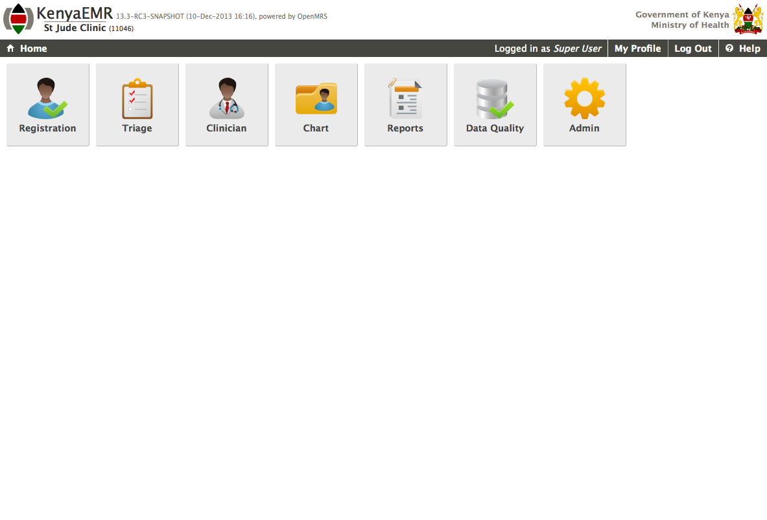

Figure : KenyaEMR Home Page (Rowan, 2018)

1. District Health Information Software Version 2(DHIS2)

DHIS2 is used for collecting, managing, and analyzing health data across health institutions. It allows for data to be aggregated from the healthcare systems and used across multiple levels of the health system. The system is accessible to health records officers who are responsible for data management at the health facility. DHIS2 was implemented as a response to challenges faced by preceding Microsoft Excel file-based systems that contained aggregated data that was harder to analyze, lack of error-checking mechanisms and presence of incomplete data which hindered the ability to utilize the data collected for decision making (Muinga et al., 2018).

1. MedRec

MedRec is an EHR system that was initially built using the ethereum blockchain that prioritizes ease of access to health records by the patient while giving a comprehensive, transparent, and easily accessible view of medical history in the system.

1. Akiri

Akiri is a EHR platform supported by the American Medical Association that utilizes blockchain technology to create a trusted permission based network for sharing health data while ensuring only people authorized to access the health data can make changes to the data.

## Challenges encountered by Existing Health Record Systems

The following are some of the challenges facing the electronic health record systems in place, they include:

### Lack of Interoperability

Interoperability is how different systems to exchange information between them. There is lack of complete interoperability between the health systems in place due to lack of tools to facilitate sharing of data between health institutions and presence of insecure systems that are prone to attacks thus risking sensitive health records.

This brings in the possibility of having conflicting patients records in different institutions. A patients health record could have been updated in one institution, but other institutions are not aware of the changes made to the patients records thus would inaccurate data.

### Data breaches and Fraud

Health systems have been attacked for many years by hackers in an attempt to gain access to stored private health records for the purpose of sharing them online, modifying them or using them for extortion.

In 2016, a hacker by the name of "thedarkoverlord" stole over 650,000 medical records from the databases of three separate healthcare institutions. The hacker sold the medical records for hundreds of thousands of dollars online and extorted health institutions by demanding money to prevent further attacks and distribution of records. Additionally, in 2015, more than 100 million health records were compromised(Nguyen, 2017).

Apart from unauthorized access and stealing patient records, hacker may commit fraud using the patient records i. e. prescription and insurance fraud.

Prescription fraud is when the details of a prescription are modified so as one can receive certain medications that cannot be obtained normally while Insurance fraud occurs when there is entry of incorrect diagnosis of a patient so as file for false insurance claims which in turn results to expensive healthcare costs for the patient.(Shuaib et al., 2019)

### Fragmentation of data

Patients tend to move from one health institution to another either due to cost, convenience or better services being offered. The utilization of different health institutions by patients bring about the issue of fragmentation of data where there exist different versions of patient health records in different health institutions. This hinders the health institutions visited from giving better treatment to patients due to usage of data that is not up to date that may contain existing ailments and treatments being administered to the patient.

### Information Asymmetry

Information asymmetry is a situation where some healthcare institutions have better access to health records than patients or other healthcare institutions. This can be due to healthcare institutions refusing to share records to institutions that are less secure to prevent compromising secure data or as an effort to monopolize health records inside their own health institutions in order to bring in profits.

Health institutions have better access to patient health records than the patients themselves. It is a time-consuming and tedious process for patients to access their health records information while there being no mechanism for patients to limit who can access their health records.

## The Blockchain concept

The following section will look into blockchain technology and how its application in electronic health record systems.

1. Blockchain Technology

Blockchain technology was designed by Satoshi Nakamoto in 2008 for the purpose of having a decentralized currency that was cryptographically secure which would be helpful for financial transactions (Shahnaz et al., 2019). Blockchain technology has potential uses in a majority of fields one of them being in storage and sharing of health records.

A blockchain is essentially made up of a block, the chain, a network of nodes and rules that that are established when the blockchain is generated that validate transactions before they are entered into the blockchain. A blockchain holds information about transactions and whether the transactions are valid.

To ensure valid entries are entered into the blockchain, a smart contract is utilized. A smart contract is a series of if/then statements that are programmed and stored inside the blockchain. The smart contract is automatically executed, and the transaction stored inside the blockchain and shared across the blockchain once the contract’s requirements are met (Bhatia et al., 2020).

A block is a list of recorded transactions over a period of time. Addition of multiple blocks into the networks brings about the “blockchain”. The chain is when the block is linked to its preceding block through a hash. A new block contains the hash value of the previous block thus enforcing the chain since if a block is altered, the hash values would be different (“National Archives and Records Administration,” 2019).

Cryptographic hashes are strong one-way functions that generate checksum for digital data that cannot be used for data extraction (Shahnaz et al., 2019). A hash is a function that converts an input of letters and numbers into an encrypted output of a fixed length(Frankenfield, 2019). A Merkle root is the hash of all the hashes of all the transactions that are in a block in a blockchain network (Frankenfield, 2020)

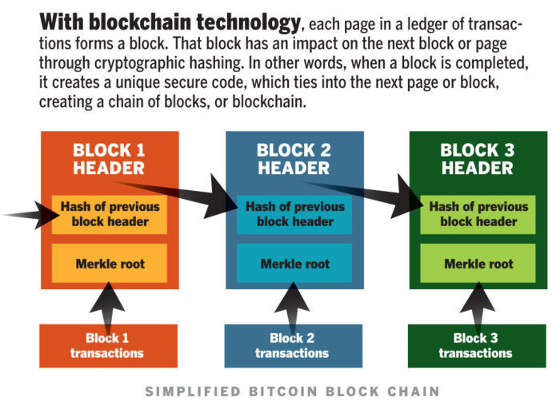

Figure : Simplified Blockchain (Mearian, 2019)

For example, the Secure Hashing Algorithm (SHA-256) generates varying hash values for different spellings of the word “Computer Science” from the Xorbin hash calculator (Xorbin, 2018) .

|  |  |
| --- | --- |
| **Word Variation** | **Hash Value** |
| Computer Science | 445ddaa59df684ea81e04e1b2aad2ec113a4a8a36ce8c5e802c1542266b8921d |
| computer Science | 13a5670cc77404aa14b878e0b1a82651e705d21f7ba2956918a1406b26871a1f |
| Computerscience | c113533dba8a99e44c18f366de0feb12b9ef8d51ef862bb5e40090fe9092b475 |

Figure 4: SHA-256 Hash Variations

The blockchain is made up of nodes that contain a complete record of all transactions that are stored inside the blockchain. There is no centralized official copy of a transaction therefore no node is "trusted" more than another. A consensus mechanism is a rule or algorithm that governs how nodes validate transactions that are to be entered into the blockchain. The consensus mechanism allows for nodes to agree if an entry should be added to the blockchain thus enforce authenticity and the immutability of transactions. (“National Archives and Records Administration,” 2019).

There are three types of blockchains i.e. public, private, and permissioned. Public blockchains are large distributed networks available for anyone to participate in. Private blockchains are tightly controlled and established to share sensitive information inside an organization while permissioned blockchains have an aspect of access restrictions depending on the roles of a user or an organization when using the blockchain (Bhatia et al., 2020).

1. Key Features of a blockchain

The key features of a blockchain are decentralization, transparency, and improved security.

The blockchain is decentralized in such a way that where there is no central point of data access thus no node is more trusted than the other. The blockchain is transparent i.e. where the data inside the blockchain is distributed to all nodes in the network. There is improved security of transactions inside the blockchain network due to the use of hashes to verify transactions thus improving data integrity inside the blockchain (Shahnaz et al., 2019).

1. Application of Blockchain in electronic health record systems

The use of blockchain technology in electronic health record systems healthcare system would enable health institutions to be able to request permission to access health records from the blockchain thus giving patients more control over who sees their data, improvement of security of records since health records cannot be accessed without permission. Moreover, the blockchain is immutable hence health records cannot be tampered with as the hash values of the records would be different, and the unauthorized modification would be rejected by the consensual mechanisms in place in the blockchain. There would also be full interoperability between health institutions that would turn yield in provision of better patient care due to presence of more accurate data.(Bhatia et al., 2020)

## Conceptual design

The conceptual diagram gives visual representation of how the proposed system is going function.

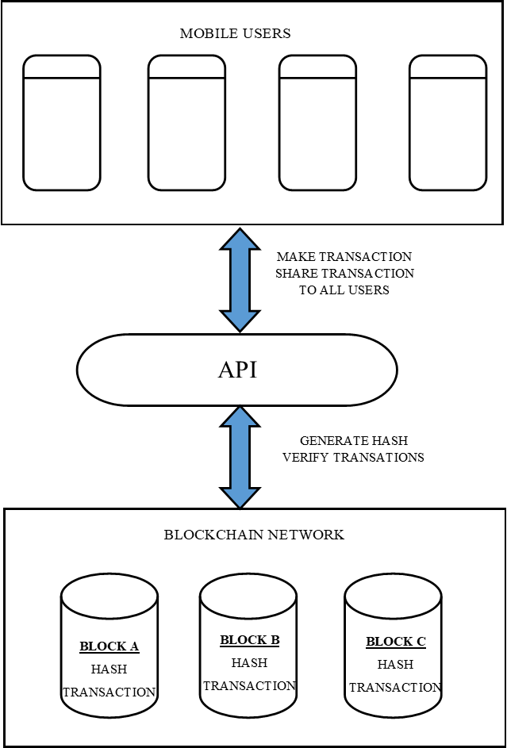

Figure 5: Conceptual Diagram

# References

Andrew, L., John D, H., Ariel, E., 2017. The Potential for Blockchain to Transform Electronic Health Records [WWW Document]. Harv. Bus. Rev. Home. URL https://hbr.org/2017/03/the-potential-for-blockchain-to-transform-electronic-health-records (accessed 6.4.20).

Bhatia, S., Douglas, E.K., Most, M., 2020. Blockchain and records management: disruptive force or new approach? Rec. Manag. J. ahead-of-print. https://doi.org/10.1108/RMJ-08-2019-0040

Connor-Green, D.S., 2017. Blockchain in Healthcare Data. Intellect. Prop. Technol. Law J. 21, 93–108.

Crypt Bytes Tech, 2017. Medicalchain — A blockchain for electronic health records [WWW Document]. Medium. URL https://medium.com/crypt-bytes-tech/medicalchain-a-blockchain-for-electronic-health-records-eef181ed14c2 (accessed 6.4.20).

Frankenfield, J., 2020. Merkle Root (Cryptocurrency) [WWW Document]. Investopedia. URL https://www.investopedia.com/terms/m/merkle-root-cryptocurrency.asp (accessed 6.14.20).

Frankenfield, J., 2019. Hash [WWW Document]. Investopedia. URL https://www.investopedia.com/terms/h/hash.asp (accessed 6.14.20).

Mearian, L., 2019. What is blockchain? The complete guide [WWW Document]. IT WORLD. URL https://www.itworld.com/article/3191077/what-is-blockchain-the-complete-guide.html (accessed 6.13.20).

Mertz, L., 2018. (Block) Chain Reaction: A Blockchain Revolution Sweeps into Health Care, Offering the Possibility for a Much-Needed Data Solution. IEEE Pulse 9, 4–7. https://doi.org/10.1109/MPUL.2018.2814879

Muinga, N., Magare, S., Monda, J., Kamau, O., Houston, S., Fraser, H., Powell, J., English, M., Paton, C., 2018. Implementing an Open Source Electronic Health Record System in Kenyan Health Care Facilities: Case Study. JMIR Med. Inform. 6, e22. https://doi.org/10.2196/medinform.8403

National Archives and Records Administration, 2019. . Blockchain White Pap.

Nguyen, B., 2017. Exploring Applications of Blockchain in Securing Electronic Medical Records. J. Health Care Law Policy 20, 99–116.

Rowan, S., 2018. KenyaEMR Distribution [WWW Document]. OpenMRS Wiki. URL https://wiki.openmrs.org/display/docs/KenyaEMR+Distribution (accessed 6.14.20).

Shahnaz, A., Qamar, U., Khalid, A., 2019. Using Blockchain for Electronic Health Records. IEEE Access 7, 147782–147795. https://doi.org/10.1109/ACCESS.2019.2946373

Shuaib, Saleous, Shuaib, Zaki, 2019. Blockchains for Secure Digitized Medicine. J. Pers. Med. 9, 35. https://doi.org/10.3390/jpm9030035

Xorbin, 2018. SHA-256 hash calculator [WWW Document]. Xorbin. URL https://xorbin.com/tools/sha256-hash-calculator (accessed 6.14.20).

# Appendix

## Appendix A: Gantt Chart

